[ Insert official UPAEP logo ]
UPAEP · Decanato de Ingenierías
EVIDENCE — US10-T4
Connect the screen to the API
SmartGreenAI: Cilantro Crop

1. Task information
Task ID | US10-T4
User Story | US-10 — Configure sensor thresholds
Sprint | Sprint 2 (2026-09-21 – 2026-10-09)
Week | Week 2
Responsible | Jorge Velez Delgado
Peer reviewer | Alexis Enrique Valle Parra
Planned / actual hours | 2 h / 2 h
Completed on | October 2, 2026
Status | Done

2. Task description
Connect the screen to GET/PUT /thresholds, show confirmation and error messages to the user.

3. Completion conditions
✓ Condition 1: Screen loads current values from GET /thresholds.
How it was verified: The screen loads its rows from GET /api/thresholds (network log: GET /api/thresholds?area_id=AREA-1 → 200).
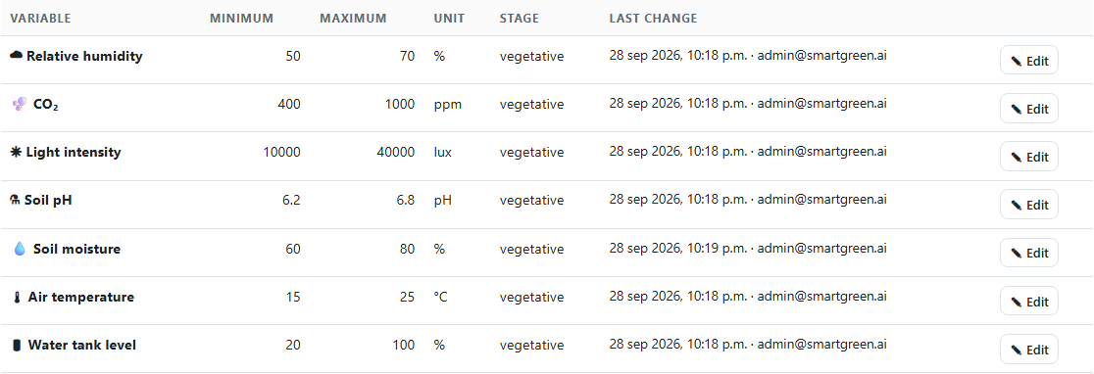
Figure US10-T4-1. The screen loads the current values from GET /api/thresholds?area_id=AREA-1. (US10-T4_Connect_Screen_API_1.png)
public/js/pages/thresholds.js — lines 20–33
async function load() {
try {
const rows = await get('/thresholds', { area_id: areaSel.value });
if (!rows.length) { clear(body, h('div', { class: 'empty' }, 'This area has no thresholds. Assign a crop type to configure them automatically.')); return; }
const tbody = h('tbody');
rows.forEach((t) => tbody.appendChild(renderRow(t)));
clear(body, h('div', { class: 'table-wrap' }, h('table', {},
h('thead', {}, h('tr', {}, ['Variable', 'Minimum', 'Maximum', 'Unit', 'Stage', 'Last change', ''].map((c) => h('th', {}, c)))),
tbody)));
} catch (err) { showError(err); }
}
function renderRow(t) {
const tr = h('tr', { 'data-type': t.sensor_type });

✓ Condition 2: Saving calls PUT /thresholds and the DB is updated.
How it was verified: Saving calls PUT /api/thresholds/{id} and the database is updated: temperature minimum 15.000 → 16 °C, updated_by admin@smartgreen.ai. The value was restored to 15 °C after the test.
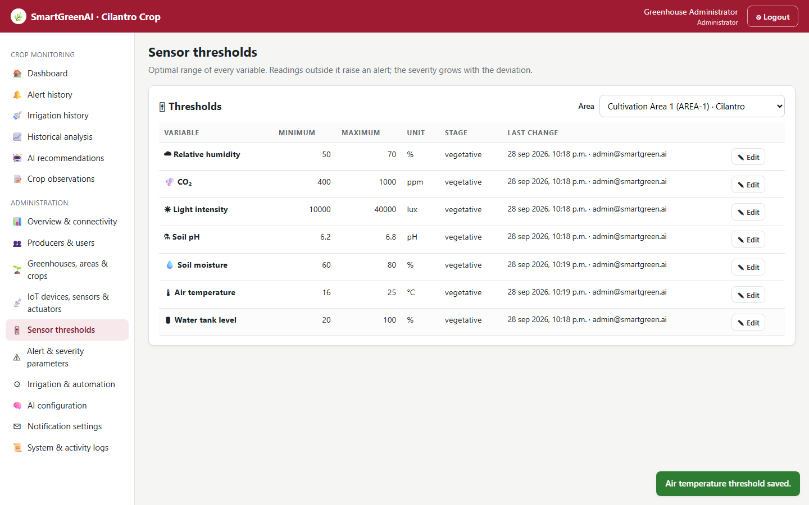
Figure US10-T4-2. Saving calls PUT /api/thresholds/th-a1-temperature; the confirmation "Air temperature threshold saved." is shown. (US10-T4_Connect_Screen_API_2.png)
Database after saving from the screen (1 rows; US10-T4_Connect_Screen_API_3.csv)
id | min_value | max_value | updated_by | updated_at
th-a1-temperature | 16.000 | 25.000 | admin@smartgreen.ai | 2026-09-29T04:19:12.083Z
SQL: SELECT t.id, t.min_value, t.max_value, u.email AS updated_by, t.updated_at FROM thresholds t LEFT JOIN users u ON u.id = t.updated_by WHERE t.id = 'th-a1-temperature'
Network calls made by the screen
GET /api/thresholds?area_id=AREA-1 → 200
PUT /api/thresholds/th-a1-temperature → 200
PUT /api/thresholds/th-a1-temperature → 400

✓ Condition 3: Success and error messages are shown to the user.
How it was verified: Success (green confirmation) and error messages (in the edited row) are shown to the user.
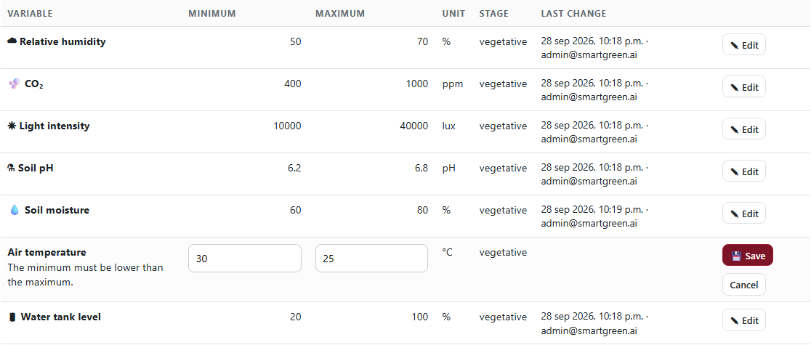
Figure US10-T4-3. Error message shown by the screen: minimum greater than the maximum. (US10-T4_Connect_Screen_API_5.png)
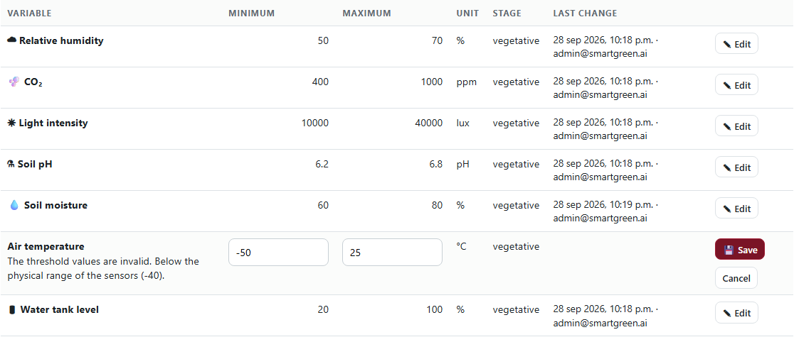
Figure US10-T4-4. Error message returned by the API and shown in the row: value outside the physical range of the sensor. (US10-T4_Connect_Screen_API_6.png)
✓ Condition 4: Evidence: Changes made on the screen are reflected in the database.
How it was verified: The change made on the screen is reflected in the database (condition 2).

4. Attached files
- US10-T4_Connect_Screen_API_1.png
- US10-T4_Connect_Screen_API_2.png
- US10-T4_Connect_Screen_API_3.csv
- US10-T4_Connect_Screen_API_4.sql
- US10-T4_Connect_Screen_API_5.png
- US10-T4_Connect_Screen_API_6.png

5. Traceability
Related requirements | FR-12, NFR-06
Implementation | See docs/TRACEABILITY.md
Verification | See docs/TRACEABILITY.md

6. Sign-off
Role | Name | Date | Signature
Responsible | Jorge Velez Delgado | October 2, 2026
Peer reviewer | Alexis Enrique Valle Parra | October 2, 2026
Product Owner acceptance | Alexis Enrique Valle Parra | October 2, 2026
Approval record: Daily Meeting 3 of Sprint 2 (Monday, October 5, 2026), team update: Jorge Velez Delgado — "US10-T3 and US10-T4 finished; thresholds saved with user and date."

